Specialized Foster Care at
Family & Children’s Agency

Because every child deserves
a loving home.

Thank you for considering becoming a foster parent with
Family & Children’s Agency.
If you or someone you know is interested in becoming a foster parent
and transforming the life of a child, please join us or contact
Karen Clark at (203) 523-5329 or at kclark@fcagency.org.

Date: March 23, 2016
Time: 5:30 to 6:30 pm
Location: Family & Children’s Agency, 140 Water Street, Norwalk, CT

You can make a difference through family foster care!
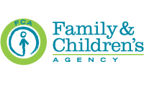
140 Water Street | Norwalk, CT 06850 | (203) 523-5329| (203) 604-1229 (Fax)
www.FamilyandChildrensAgency.org

